**How to convert HTML to PDF in Windows docker container**

Syncfusion® [HTML to PDF for .NET Core](https://www.syncfusion.com/document-processing/pdf-framework/net/html-to-pdf) is used to convert webpages, SVG, MHTML, and HTML to PDF. Using this library, you can convert HTML to PDF in Windows docker using the Linux HTML converter.

Docker for Windows

Docker for windows can be downloaded from <https://www.docker.com/docker-windows>

Switch between Windows and Linux containers

From the Docker for Windows menu, you can toggle daemon (Linux or Windows) which the Docker CLI talks to. Select *Switch to Windows containers* to use windows containers or select *Switch to Linux containers* to use Linux containers (the default). 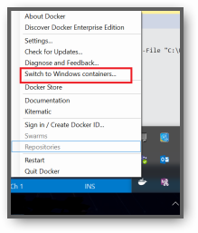

Steps to convert HTML to PDF in Windows docker container programmatically:

1. Create a new C# ASP.NET Core Web application project.

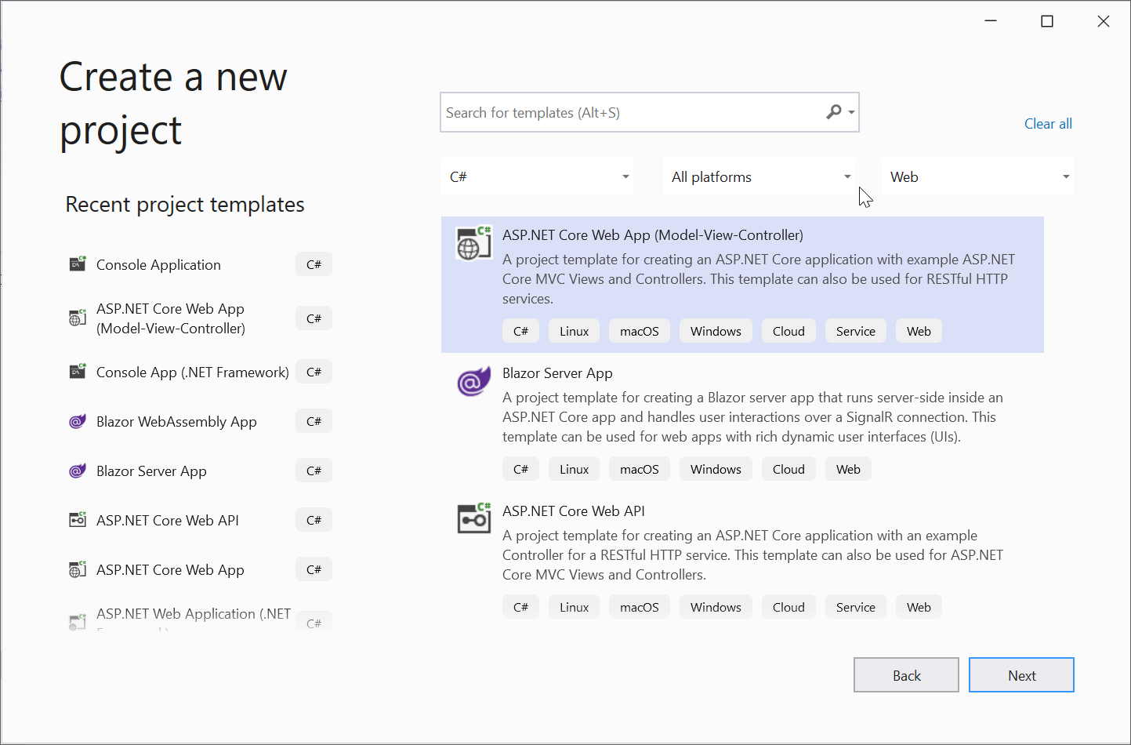

1. Enable docker support and select target OS as Windows.

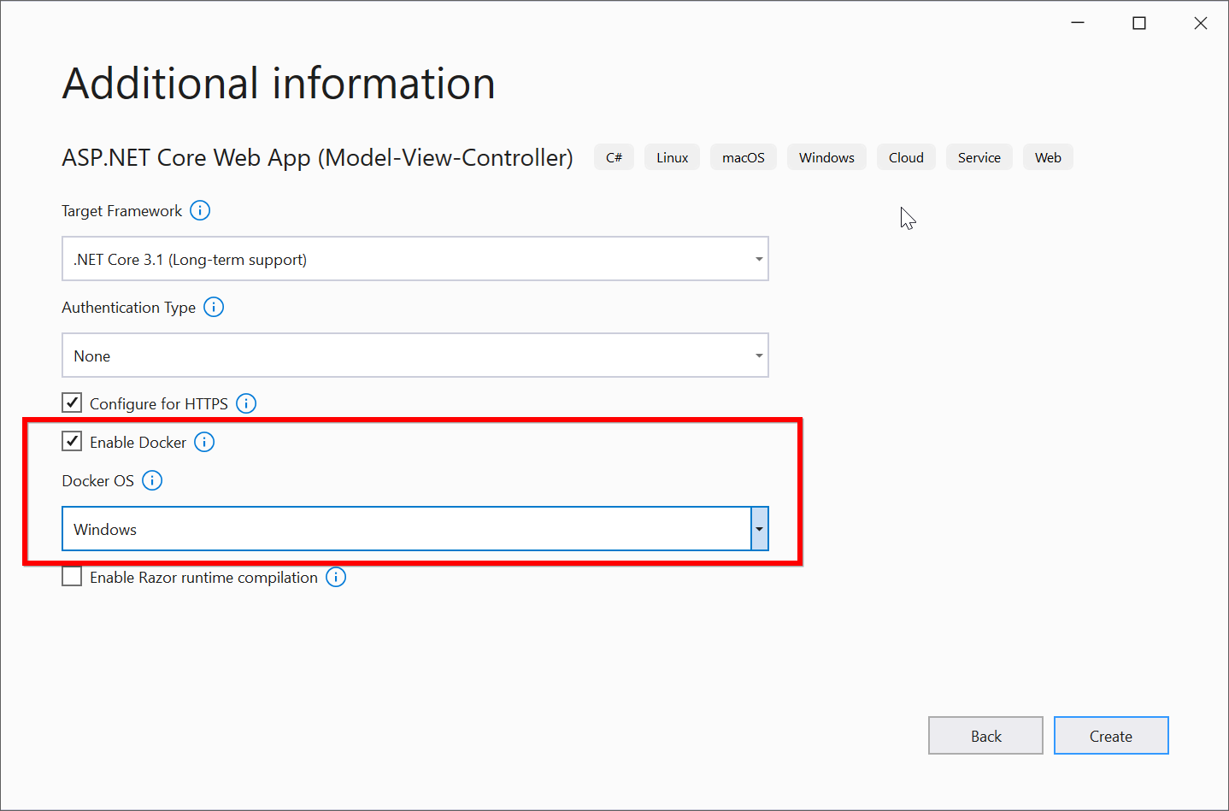

1. Install the [Syncfusion.HtmlToPdfConverter.Net.Windows](https://www.nuget.org/packages/Syncfusion.HtmlToPdfConverter.Net.Windows/" \t "_blank) NuGet package as reference to your .NET Core application from [NuGet.org](https://www.nuget.org/).

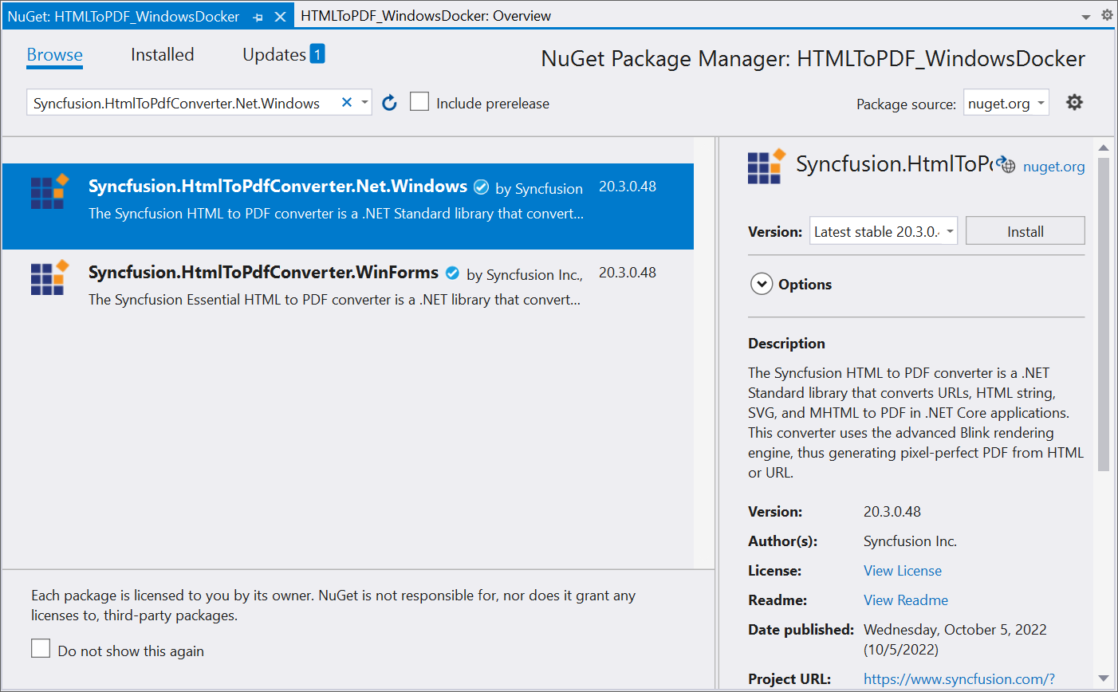

Note:

Microsoft provided docker image for ASP.NET core using nanoserver image. To provide light weight image, nanoserver removes lots of Windows API and it supports 64-bit application only. Due to this, the wrapper is not compatible with nanoserver image. So, conversion getting failed in nanoserver docker containers.

1. Add a new button in **index.cshtml** as follows.
2. <h2>Click the button to generate PDF</h2>
3. @using (Html.BeginForm("ExportToPDF", "Home", FormMethod.Post))
4. {
5. <input type="submit" value="Export to PDF" />
6. }

1. Include the following namespaces in **HomeController.cs** file.

**C#**

**using** Syncfusion.Pdf;

**using** Syncfusion.HtmlConverter;

1. Add the following code snippet to convert HTML to PDF.

**C#**

public IActionResult ExportToPDF()

{

     //Initialize HTML to PDF converter

     HtmlToPdfConverter htmlConverter = **new** HtmlToPdfConverter();

     //Convert URL to PDF

     PdfDocument document = htmlConverter.Convert("https://www.syncfusion.com");

     MemoryStream stream = **new** MemoryStream();

     //Save and close the PDF document

     document.Save(stream);

     return File(stream.ToArray(), System.Net.Mime.MediaTypeNames.Application.Pdf, "Sample.pdf");

}

Build and Run the application in Docker and the webpage will open in the browser. Click export to PDF button to convert HTML to PDF in Windows docker container. You will get the PDF document as follows. 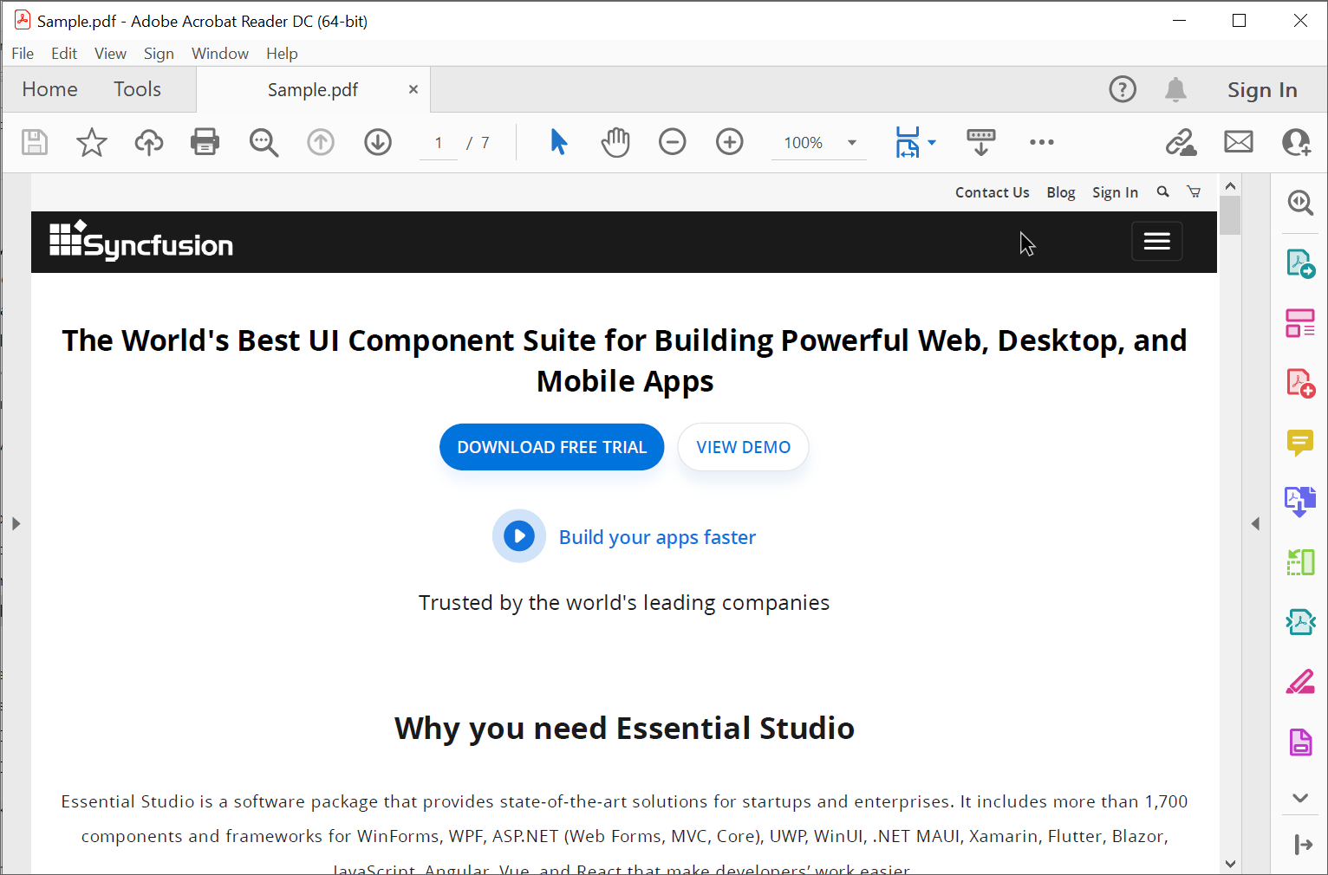

Take a moment to peruse the documentation for [converting HTML to PDF](https://help.syncfusion.com/file-formats/pdf/converting-html-to-pdf), where you will find other options like [HTML string to PDF](https://help.syncfusion.com/file-formats/pdf/converting-html-to-pdf#html-string-to-pdf), [partial webpage to PDF](https://help.syncfusion.com/file-formats/pdf/converting-html-to-pdf#partial-webpage-to-pdf), [HTML to single PDF page](https://help.syncfusion.com/file-formats/pdf/converting-html-to-pdf#html-to-single-pdf-page), and [HTML to PDF conversion using IE Rendering](https://help.syncfusion.com/file-formats/pdf/converting-html-to-pdf#conversion-using-ie-rendering) with code examples.

A complete work sample can be downloaded from [HTMLToPDF\_WindowsDocker.zip](https://www.syncfusion.com/downloads/support/directtrac/general/ze/HTMLToPDF_WindowsDocker-1718272640)

**See Also:**

[HTML to PDF conversion in Linux docker container](https://support.syncfusion.com/kb/article/7651/how-to-convert-html-to-pdf-in-linux-docker-container-aspnet-pdf)